**Home**

Company Logos one below other

Sk Group Logo

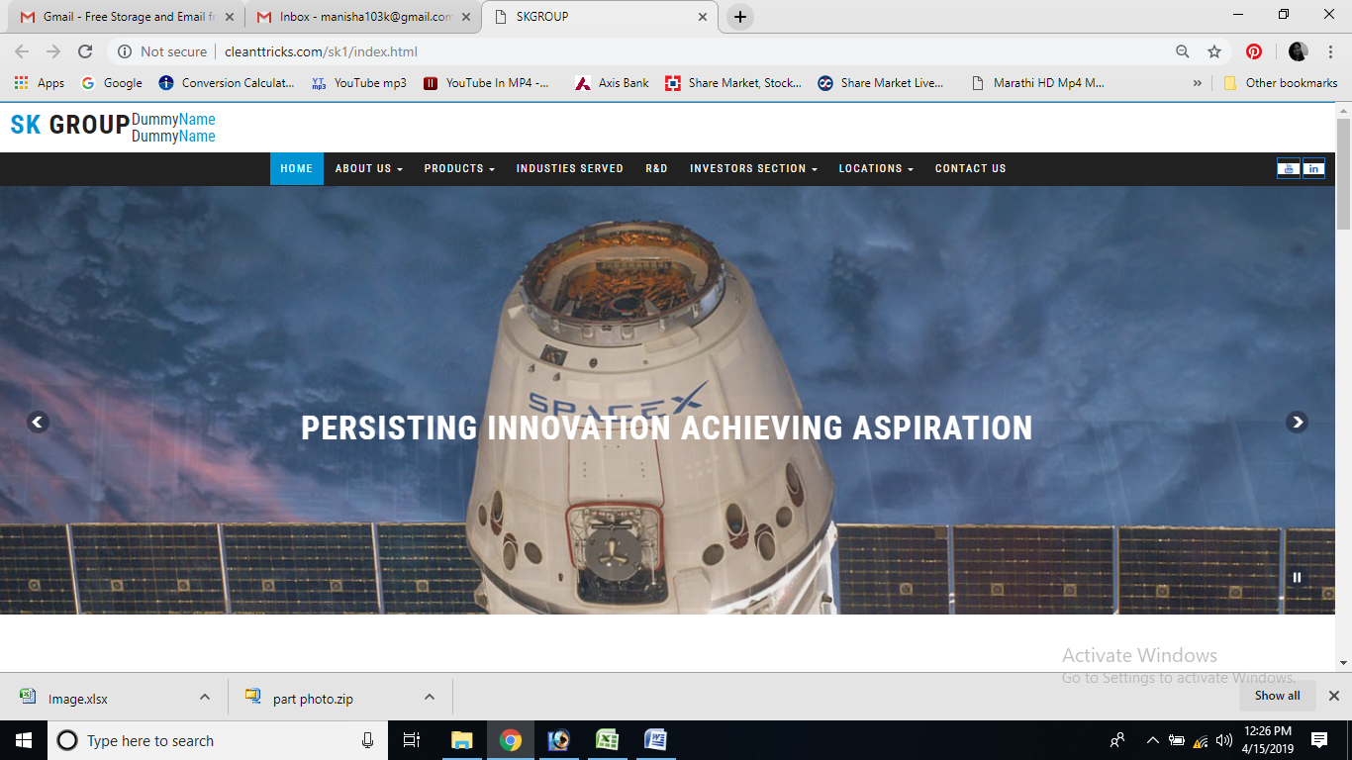

You tube logo not visible

Line to get down

Slide Image 1, 2,3

**Text for Home page**

**The SK Group –** comprising of **Sellowrap Industries Pvt. Ltd.** and **Sellowrap EPP India Pvt. Ltd.,** produce customized components for the best Automobile and Non Automobile brands in the industry for Domestic as well as Export market.

**Products**

**Sellowrap**® is highly competitive and low cost supplier, manufacturing different grades of NVH foam products, blow films and moulded plastic components.

Below product names with content add place for image

1. EPP Molding - Tool Kit, Bumper- Core,Core Seat, Packaging, Foot Rest, Rear Bracket Bumper
2. Foam Products - Door Protector, NVH, Insul Pillars
3. PU Foam Molding - Cover Fenders, Baffle, Seal Hinge , Hood Parts etc.
4. Plastic Injection Molding - Fasteners, Tumble Hooks, Grip Assist, Handle Window Regulators, Sunvisor Holder, Dummy Plugs, Support Microphones, Air Spoilers, Speaker Covers & Insul Fenders.
5. Screen Sealing - Door Protective Films
6. Stickers & Lables - Engine Cooling Fan, Safety Lock, CNG Seals, Unleaded Fuel Free Lock, Tire Pressure Labels, Caution Labels etc

Remove Mission & Values , Keep only Vission with background pic

**Press Release - Has to be with pic & content**

**Vission**

CREATING PATHS FOR DESIGNING A SUCCESSFUL FUTURE